1. **What is this query about?**

|  |
| --- |
| SELECT        emp_no, AVG(salary)    FROM        salaries    GROUP BY emp_no    HAVING AVG(salary) > 120000    ORDER BY emp_no; |

This query is about extracting the average salary obtained by employees only when the salary value is larger than 120,000 dollars.

# **2. Getting the first or last value for each user in a `transactions` table.**

`transactions`   
+---------------+---------+   
| user_id | int |   
| created_at | datetime|   
| product | varchar |   
+---------------+---------+ **Question:** Given the user transactions table above, write a query to get the first purchase for each user.

**Why does this matter?** How would you query for the first time a person commented on a post and read the post itself? How do we cohort users by start date? All of these analyses need this concept of querying based on first or last time and it definitely can be solved without using an expensive partition function.

**Explanation:**

We want to take a table that looks like this:

user_id | created_at | product   
 --------+------------+--------  
 123 | 2019-01-01 | apple   
 456 | 2019-01-02 | banana   
 123 | 2019-01-05 | pear   
 456 | 2019-01-10 | apple   
 789 | 2019-01-11 | banana and turn it into this

user_id | created_at | product   
---------+------------+--------  
 123 | 2019-01-01 | apple   
 456 | 2019-01-02 | banana   
 789 | 2019-01-11 | banana How do we get there?

We can solve this problem by doing a **multi-column** join.

First, how do we figure out the first time each user purchased? This should be pretty simple and can be done by a simply GROUP BY aggregation and aggregating for the minimum datetime. Notice how the table has a created_at column. This is the column that determines which row is the first purchase for the specific user, so we can write a query with an aggregation to get the **minimum**datetime for every user.

SELECT user_id, MIN(created_at) AS min_created_at  
FROM transactions  
GROUP BY 1

## ****3. List the ways to get the count of records in a table?****

To count the number of records in a table, you can use the below commands:

SELECT * FROM table1

SELECT COUNT(*) FROM table1

## ****4. Write a SQL query to find the names of employees that begin with ‘A’?****

To display name of the employees that begin with ‘A’, type in the below command:

SELECT * FROM Table_name WHERE EmpName like 'A%'

## ****5. How can you fetch common records from two tables?****

You can fetch common records from two tables using INTERSECT. For example:

Select studentID from student. <strong>INTERSECT </strong> Select StudentID from Exam

## 6. How can you fetch alternate records from a table?

## Select prodid,ProdName from products1 group by prodid having mod(prodid,2) = 1;

## Select prodid,ProdName from products1 group by prodid having mod(prodid,2) = 0;

## 7. How can you select unique records from a table?

You can select unique records from a table by using the DISTINCT keyword.

Select DISTINCT studentID from Student

Using this command, it will print unique student id from the table Student.

## 8. How can you fetch first 5 characters of the string?

There are a lot of ways to fetch characters from a string. For example:

Select SUBSTRING(StudentName,1,5) as studentname from student

### **9. Consider the below Employee_Details table. Here the table has various features such as Employee_Id, EmployeeName, Age, Gender, and Shift. The Shift has m = Morning Shift and e = Evening Shift. Now, you have to swap the ‘m’ and the ‘e’ values and vice versa, with a single update query.**

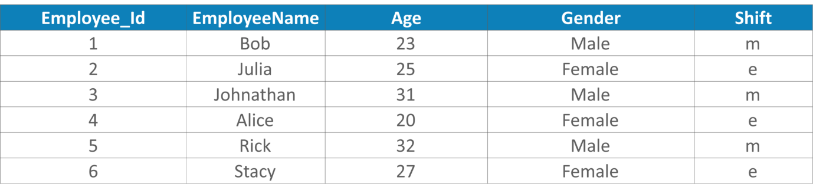

You can write the below query:

UUPDATE Employee_Details SET Shift = CASE Shift WHEN 'm' THEN 'e' ELSE 'm' END

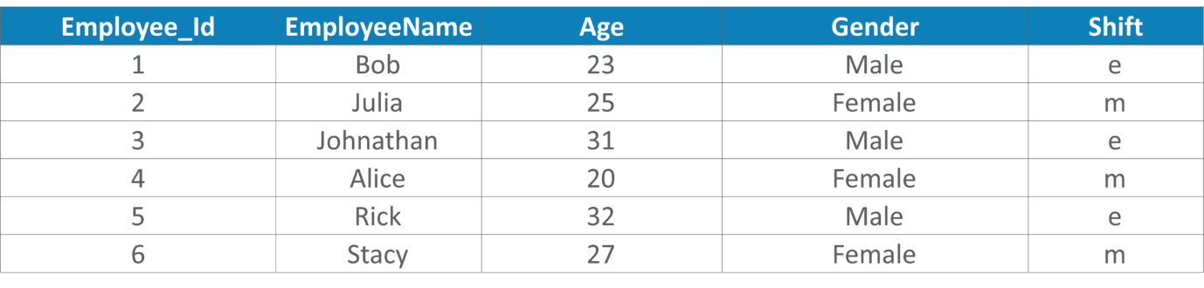

#### **10.write the query to find the distinct domain from email column, consider the below employee table for example?**

|  |  |
| --- | --- |
| Name | Email |
| Anubhav | [anubhavraj@gmail.com](mailto:anubhavraj@gmail.com) |
| Basant | [basantverma@yahoo.in](mailto:basantverma@yahoo.in) |
| Sumit | [Sumitsinha@hotmail.com](mailto:Sumitsinha@hotmail.com) |
| Amit | [anuragamit@gmail.com](mailto:anuragamit@gmail.com) |

So write the query to get the result only @gmail.com, @yahoo.in, @hotmail.com (Since we have two gmail.com and we need to fetch only distinct domain).

**Answer:**  
Select distinct (substr (Email, Instr (Email,’@’,1,1))) from employee;

#### 8. Write the query to remove the duplicates from a table without using a temporary table?

**Answer:**  
Delete from Employee where name in (Select name from employee group by age, salary having count(*) > 1));

#### 9. Write a SQL query to create a new table with data and structure copied from another table, create an empty table with the same structure as some other table?

**Answer:**  
create a new table with data and structure copied from another table  
Select * into new table from an existing table;  
Create an empty table with the same structure as some other table  
Select * into new_table from existing_table where 1=2;

#### 10. Write a SQL query to find the common records between two tables?

**Answer:**  
Select * from table_one  
Intersect  
Select * from table_two;

#### 11. Write a SQL query to find the records that are present in one table but missing in another table?

**Answer:**  
Select * from table_one  
Minus  
Select * from table_two;

I am taking one example, The company has a 100 employees it’s running from last 5 years, Some people are experienced and some people freshers. The starting exp is 0 and maximum is 10. Employee salaries starts from 10,000 to 1,00,000

1. Can you write query to create a employee table ?
2. Can you write query to Insert values employee ?
3. Can you insert a employee without his id ?
4. Can you write a query to update values in database for single column?
5. Can you write a query to display top 10 salaries of employees ?
6. Can you write a query to display 3 most highest salary for this company ?
7. Can you write a query to display to display freshers in company ?
8. Can you write a query to display to retrieve highest experienced employee in company ?
9. Can you write a query to display to retrieve old employee in company ?
10. Can you write a query to how many no of employees left in this company ?
11. Can you write a query to display freshers and above 5 years experience employees in company ?
12. What is current burning rate for company with all employees salaries for monthly ?
13. How many male employees in company ? what is avg salary for them ?
14. How many female employees in company ? what is avg salary for them ?
15. How many 5+ exp employees in company ? what is avg salary for them ?
16. How many persons join to our company in the last month ?
17. Who is the new employee in our company ?
18. Which employee has highest exp in our company ?